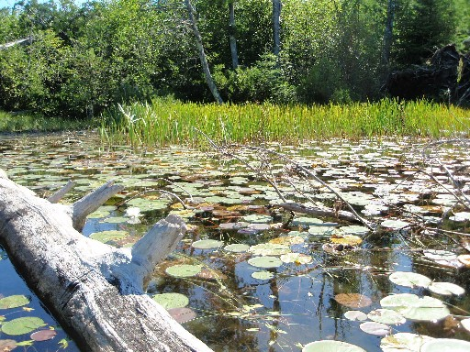
Title – Cook County Lake Management Plan
Creation Date
Any other information

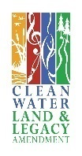
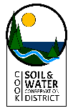
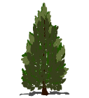
Cook County Coalition of Lakes sAssociations
Authors:

Plan Development Committee Members:

Contributors:
Minnesota Pollution Control Agency
Minnesota Department of Natural Resources
Cook County Soil and Water Conservation District
Cook County Land Services
United States Forest Service
Cook County Aquatic Invasive Species Coordinator
Cook County Coalition of Lake Associations

Table of Contents:
Introduction
Purpose
Goals
Regional Characteristics
Lake Characteristics
Watershed
Land Use Characteristics
Lake Characteristics
Recreation Use
Fisheries
Aquatic Vegetation
Water Quality
Goals and Actions
Appendix

Appendices:
MN DNR Fisheries Lake Management Report
MN DNR Sensitive Lake Study
MN BWSR Lake Assessment
CCCoLA Lake Survey 2018

Acronyms:
AIS – Aquatic Invasive Species
CCCOLA – Cook County Coalition of Lake Associations
DNR – Department of Natural Resources
HUC – Hydological Unit Code
MN - Minnesota
MPCA – Minnesota Pollution Control Agency
SWCD – Soil and Water Conservation District
USFS – United States Forest Service

Resources:
Lake Superior North One Watershed, One Plan Comprehensive Plan
MN DNR Lake Finder Information Website
MPCA – Lake Superior North Watershed, Watershed Restoration and Protection Strategies Draft Report- 2018
MPCA – Rainy Rivers Headwaters Watershed Monitoring and Assessment Report – 2018
Cook County Comprehensive Water Management Plan

Introduction:
(Include if this is your watershed) Lake Superior North Watershed – XXXX Lake is located in Cook County in the northern part of Minnesota within the Lake Superior North Watershed. The Lake Superior North Watershed is part of the Northern Lakes and Forest ecoregion. The area varies in landscape from pristine wetlands to lakes and streams with elevation changes of over 1,000 vertical feet. The streams and rivers are flat, forested and connected with wetlands at the headwaters and throughout most of the length of the streams. As they reach Lake Superior, the elevation change creates more energy of the waterway with waterfalls and changing shorelines. There are over 600 lakes in the watershed. Some of the area is protected in the Boundary Waters Canoe Area Wilderness (BWCAW). Most of the watershed is undeveloped. The water resources have been found to be pristine and have many of the state’s highest water quality. Lakes which are found throughout the watershed have some of the highest pressure for development in the area. (MPCA – Lake Superior North Watershed, Watershed Restoration and Protection Strategies Draft Report 2018)

(Include if this is your watershed) Rainy River Headwaters Watershed – XXXX Lake is located in Cook County in the northern part of Minnesota within the Rainy River Headwaters Watershed. A large portion of this watershed is within Ontario, Canada. Cook County makes up 11.01% of the watershed with a large percentage of this in the Boundary Waters Canoe Area Wilderness (BWCAW). The region is part of the Northern Lakes and Forest ecoregion. It is an area with steep, rolling hills, broad lacustrine basins, sandy washout plains and heavily forested. The lakes in the region are of high quality, clear and without much productivity. Wetland and bog areas can be found throughout the watershed. The water resources have been found to be pristine and have many of the state’s highest water quality. Lakes outside of the BWCAW have the highest pressure for development in the area. (MPCA – Rainy River Headwaters Watershed Monitoring and Assessment Report -2018)

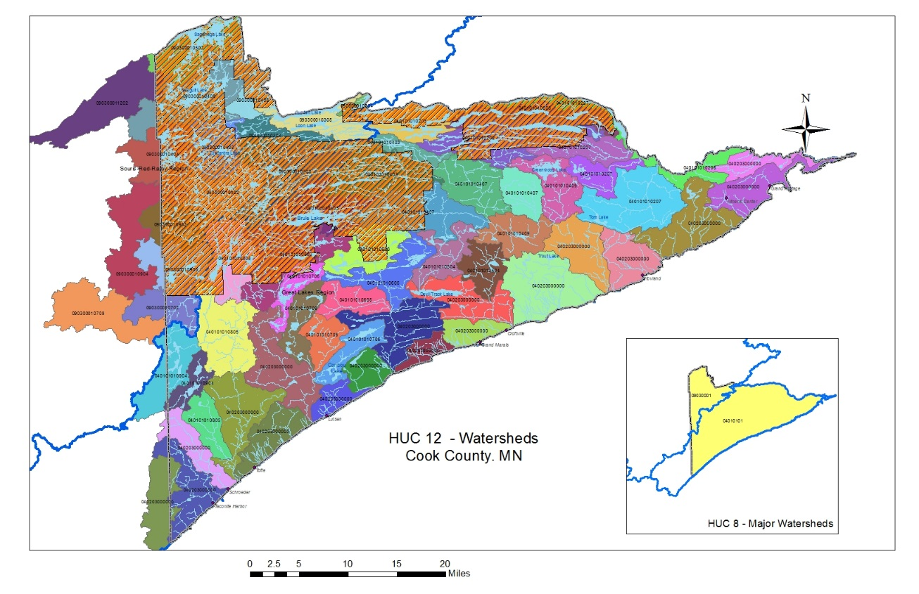

Purpose: The purpose of this lake management plan is to provide guidance to prevent or solve problems that may harm XXXXX and its watershed.
In July 2018, Cook County Soil and Water partnered with Cook County Coalition of Lakes Associations with support from a grant from MPCA, to facilitate the development of Lake Management Plans for CCCoLA members’ lakes. A survey was developed to collect data from lake and watershed property owners regarding lake health, shoreline development, and land use in the watershed. The data collected through this survey has guided lake members as they develop action plans regarding areas of concern and identify positive XXXXX Using a collaborative model in developing individual lakes plans throughout Cook County, allows for continued support for lake and property owners as they implement their action plans. This survey can used again in 10 years to update lake plans and to monitor the changes at members’ lakes.
Who can use this plan, and how can it be used?
Individuals: Individuals can use this plan to learn about the lake they love and their connection to it. People living near XXXX Lake can have the greatest influence on the lake by understanding and choosing lake-friendly options to manage their land and the lake.
XXXXX Lake Association: This plan provides citizens with a well thought-out plan for the lake and lists options that can easily be prioritized. Annual review of the plan will also help members to realize their accomplishments. Resources and funding opportunities for lake management activities are made more available by placement of goals into the lake management plan, and the organization can identify partners to help achieve their goals for XXXX Lake.
Neighboring lake groups, sporting and conservation clubs: Neighboring groups with similar goals for lake stewardship can combine their efforts and provide each other with support, improve competitiveness for funding opportunities, and make efforts more enjoyable.
Cook County: County professionals will better know how to identify needs, provide support, base decisions, and allocate resources to assist in lake-related efforts documented in this plan. This plan can also inform county board supervisors in decisions related to Cook County lakes, streams, wetlands and groundwater.
Minnesota Department of Natural Resources and USFS: Professionals working with lakes in Cook County can use this plan as guidance for management activities and decisions related to the management of the resource, including the fishery, and invasive species. Lake management plans help the Minnesota Department of Natural Resources to identify and prioritize needs within Minnesota’s lake community, and decide where to apply resources and funding. A well thought-out lake management plan increases an application’s competitiveness for state funding – if multiple Cook County lakes have similar goals in their lake management plans, they can join together when seeking grant support to increase competitiveness
XXXX Lake Association
INSERT - History

INSERT - General Information – Membership (paying verses non-payers), activities, meeting times,

INSERT - Goals:

Regional Characteristics:
Cook County in northeastern Minnesota. It shares a boundary with Lake Superior, Canada, and Lake County. The County covers a total area of 3,339.72 square miles; 1,450 square miles of the area is land and 1,889.12 square miles of the area is water. The dominant land use of the area is public forest management by federal, tribal, or state management. Approximately 9% of the land base is in private property. The City of Grand Marais is the County Seat. Cook County is comprised of three townships (Schroeder, Tofte, Lutsen) and two cities (Grand Marais & Grand Portage). Grand Portage is located within tribal land on the Grand Portage Reservation.
The 2010 United States Census reported a county population of 5,176 people, a 0.2% increase in population over 10 years. The population of Cook County is not predicted to change much in the future. The long-term population projects for Cook County suggest stable to possibly slightly declining for year-round residents and increases are predicted for seasonal or part-time residents. (Cook County Comprehensive Water Management Plan).
Land Use and Zoning

Insert Map of land use and zoning for lake
Shoreland vegetation is critical to a healthy lake’s ecosystem. It helps improve the quality of the runoff that is flowing across the landscape towards the lake. It also provides habitat for many aquatic and terrestrial animals including birds, frogs, turtles, and many small and large mammals. Healthy shoreland vegetation includes a mix of tall grasses/flowers, shrubs, and trees which extend at least 40 feet landward from the water’s edge. Shorelands include adjacent wetlands, which also serve the lake by allowing contaminants to settle out, providing shelter for fish and wildlife, and decreasing the hazard of shoreline erosion by providing a shoreland barrier from waves and wind.
The water quality in XXX Lake is the result of many factors, including the underlying geology, the climate, and land management practices. Since we have little control over the climate and cannot change the geology, changes to land management practices are the primary actions that can have positive impacts on the lake’s water quality. The water quality in XXXX Lake was assessed by measuring different characteristics including temperature, dissolved oxygen, water clarity, water chemistry, and algae.
Lake Characteristics – (MNDNR Lake Finder great site for this)
Watershed:
Access to the lake

INSERT MAP
Land Use Characteristics: (examples)
Development
Terrain
Resorts

Lake Characteristics: (examples)
Lake Level
Lake Depth
Sensitive Areas
Wildlife
Recreation Use: (examples)
Boat Landings
Motor vs non
BWCA

Fisheries:

Aquatic Vegetation:

Water Quality:
Water quality of a lake is the direct result of landuse practices. The health of a lake is dependent on activities that occur in the lake, on the shore, and in the surrounding watershed. A healthy watershed and lake support fish, vegetation and other components to make the ecosystem viable. To understand the water quality, monitor takes place on a lake. The data is compiled and provides information into what is occurring in the lake and in the watershed.

INSERT General information about the lake’s water quality

Goals, Objectives, and Actions
(the information below will get duplicated several times depending on the number of goals/topics)

Topic Heading (For example – AIS)
Goal (What is the goal of this topic)
Actions | Lead person/group | Start/end dates | Resources

Description (For example – information about what AIS is, if there are species, treatment, monitoring, threats..)

Appendix
MN DNR Fisheries Lake Management Plan
MN Sensitive Lake Shores Report
RMB Environmental Labs Lake Condition Report
MN DNR Aquatic Vegetation Survey
MN DNR Lake Depth Map
Summary of Survey Results

Resources for Developing the Plan:
MN DNR Lake Finder: https://www.dnr.state.mn.us/lakefind/index.html
- Vegetation survey
- Link to MPCA water quality
- Maps
- Lake Levels
- Recreation information
MPCA – Watershed Restoration and Protection Strategies: https://www.pca.state.mn.us/water/watersheds
- Whole watershed information
- Some information on specific areas
- Is searchable
MPCA – Water Quality Site: https://www.pca.state.mn.us/water/water-quality-data
- Has data of all sites monitored on water body
RMB Environmental Lab: https://www.rmbel.info/data/
- Data from lakes monitored

